Verify Login with Valid Data

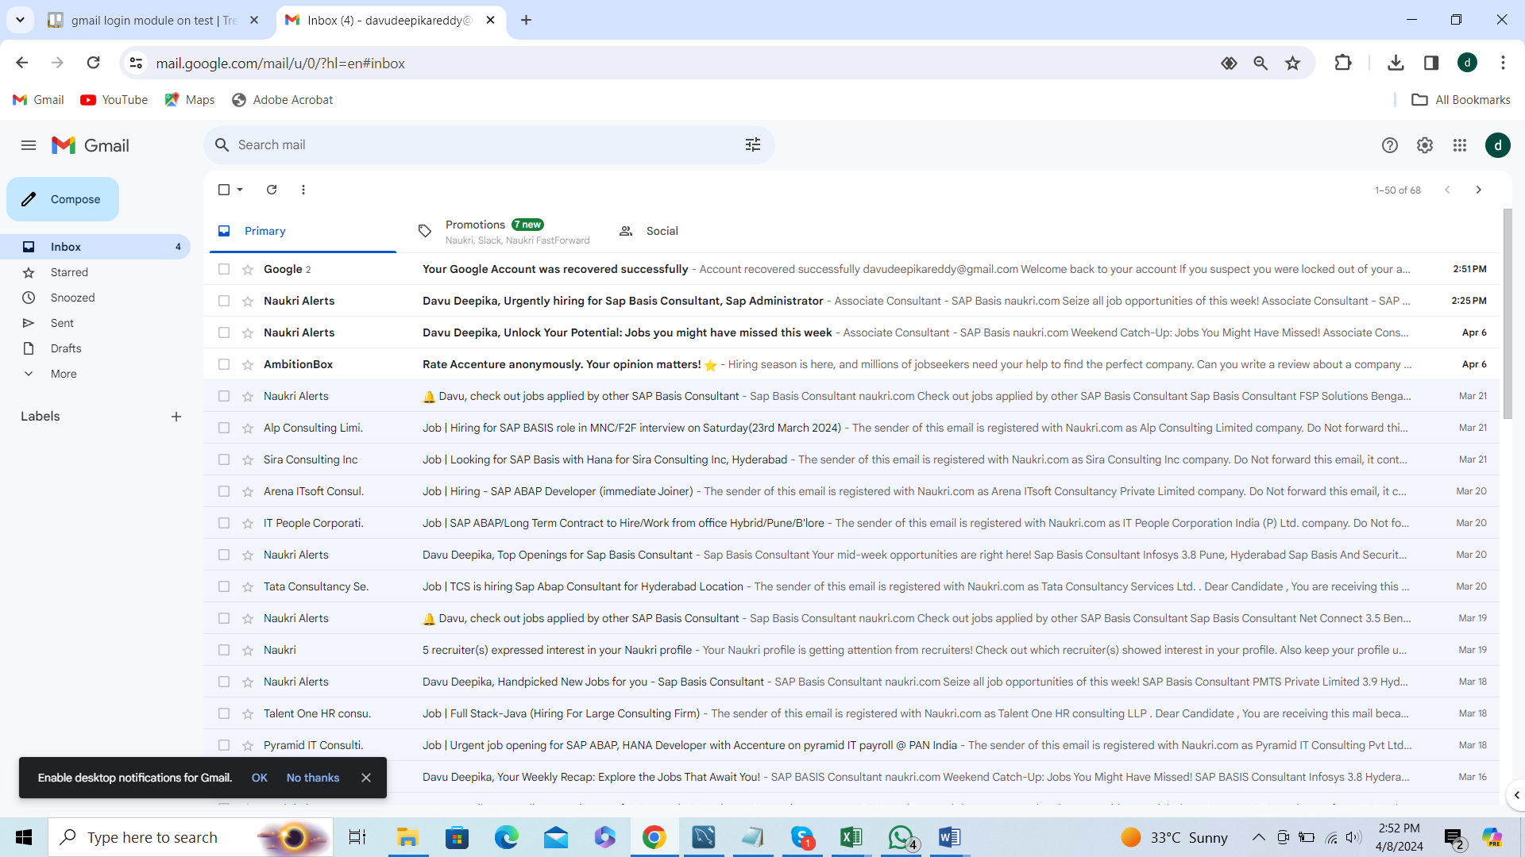

Successfully Logged in